Name : JUNYI LI

Class: CISC 504-50- A-2020

Date: 01/22/2021

Link : https://catalog.data.gov/dataset/employee-salaries-2019

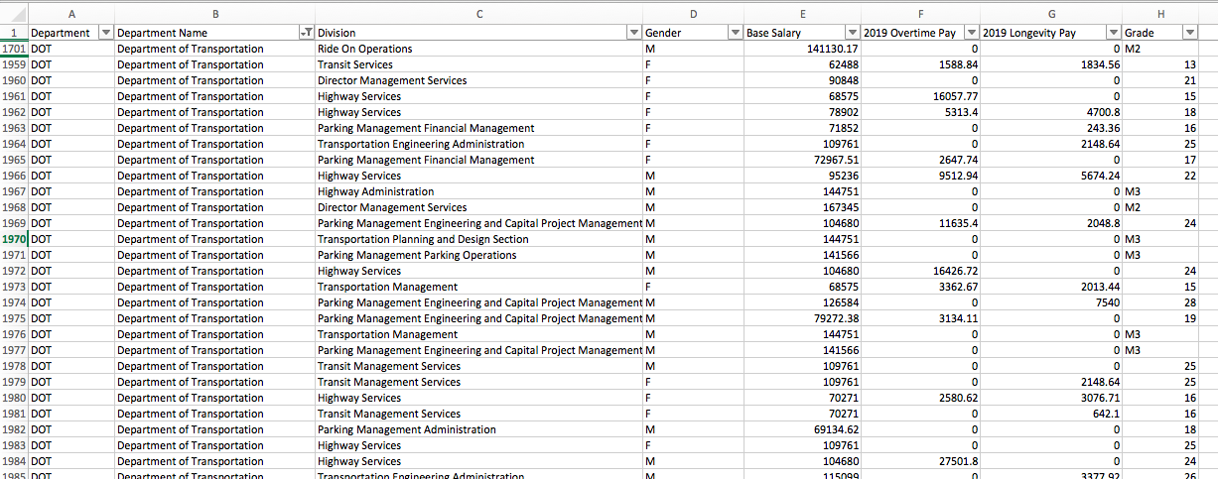

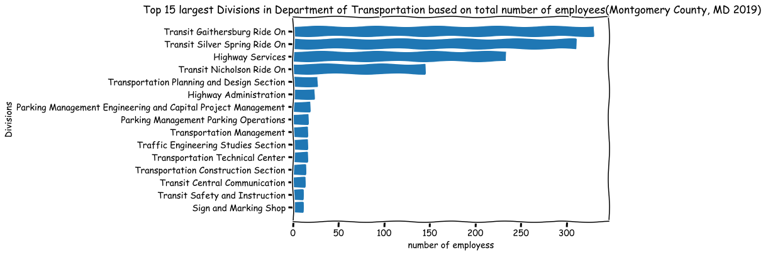Graph:

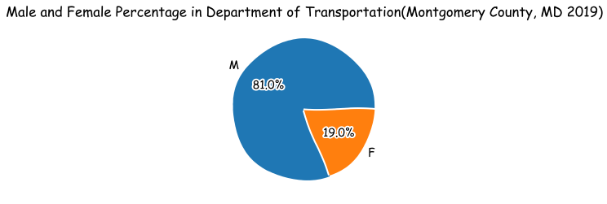

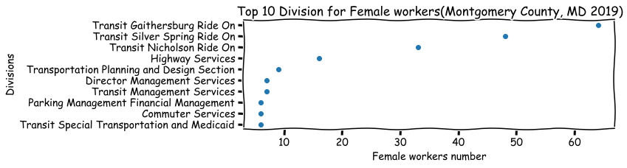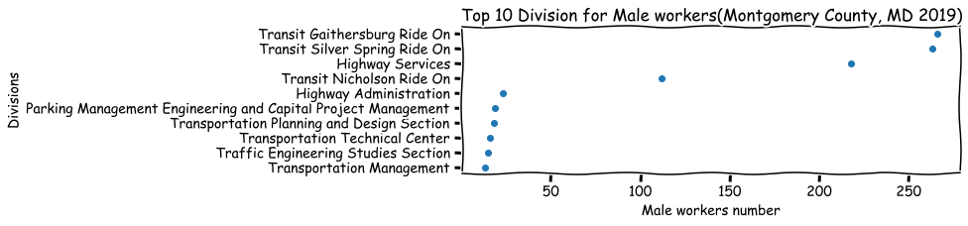

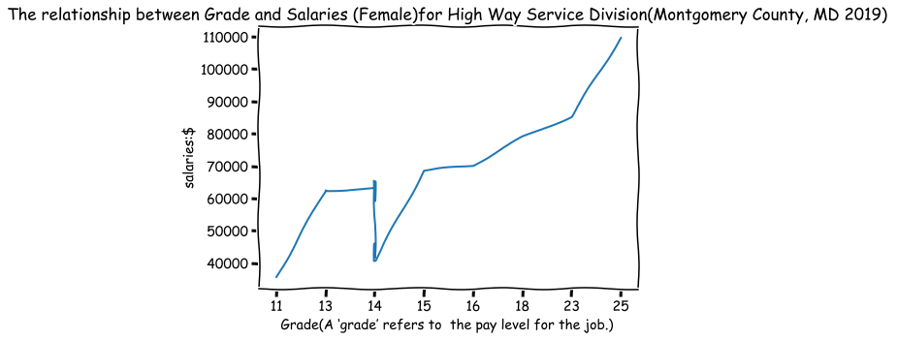

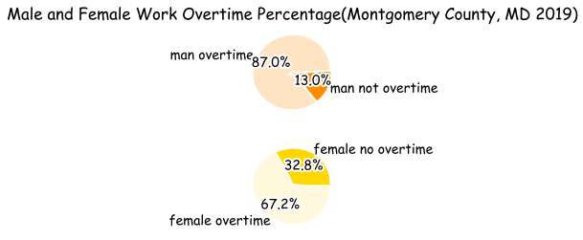

Code:

# Create an new csv document with only dataset from Department of Transportation by Pandas

import csv

import numpy as np

from collections import Counter

from matplotlib import pyplot as plt

import pandas as pd

T_df=pd.read_csv('Employee_Salaries_-_2019.csv')

filt=T_df['Department'].str.contains('DOT',na=False)

w_df=T_df.loc[filt] #filter the Department that is transportation

w_df.to_csv('transportation.csv', index=False)

# 1. Top 5 largest Divisions in Department of Transportation based on number of employees.

plt.xkcd()

with open('transportation.csv') as csv_file:

csv_reader=csv.DictReader(csv_file)#read csv

dep_counter=Counter()

for row in csv_reader:

dep_counter.update(row['Division'].split(';'))

Department=[]

num_people=[]

for item in dep_counter.most_common(15):#top 5 departments

Department.append(item[0])

num_people.append(item[1])

Department.reverse() # from largest to lowest

num_people.reverse()

plt.figure(figsize=(9,6))

plt.barh(Department,num_people)# add h to bar

plt.title('Top 15 largest Divisions in Department of Transportation based on total number of employees(Montgomery County, MD 2019)')

plt.ylabel('Divisions')

plt.xlabel('number of employess')

plt.savefig('all divsion',bbox_inches = 'tight')

# 2. Male and Female Percentages in Department of Transportation.

plt.xkcd()

with open('transportation.csv') as csv_file:

csv_reader=csv.DictReader(csv_file)#read csv

gen_counter=Counter()

for row in csv_reader:

gen_counter.update(row['Gender'].split(';'))#the way to divide them

gender=[]

num_people=[]

for item in gen_counter.most_common(5):

gender.append(item[0])

num_people.append(item[1])

plt.pie(num_people, labels=gender,autopct='%1.1f%%')

plt.title('Male and Female Percentage in Department of Transportation(Montgomery County, MD 2019)')

plt.savefig('workers percentage',bbox_inches = 'tight')

3. # Create Female workers only csv

plt.xkcd()

df=pd.read_csv('transportation.csv')

f_df=df[df['Gender']=='F'] #filter out the female

f_df.to_csv('Female_workers.csv', index=False)

with open('Female_workers.csv') as csv_file:

csv_reader=csv.DictReader(csv_file)#read csv

gen_counter=Counter()

for row in csv_reader:

gen_counter.update(row['Division'].split(';'))

division=[]

num_people=[]

for item in gen_counter.most_common(10):

division.append(item[0])

num_people.append(item[1])

# Create Male workers only csv

plt.xkcd()

df=pd.read_csv('transportation.csv')

f_df=df[df['Gender']=='M']

f_df.to_csv('Male_workers.csv', index=False)

with open('Male_workers.csv') as csv_file:

csv_reader=csv.DictReader(csv_file)#read csv

m_counter=Counter()

for row in csv_reader:

m_counter.update(row['Division'].split(';'))

m_division=[]

m_num_people=[]

for item in m_counter.most_common(10):

m_division.append(item[0])

m_num_people.append(item[1])

m_division.reverse()

m_num_people.reverse()

plt.figure(figsize=(9,6))

plt.subplot(2,1,1)

plt.scatter(m_num_people, m_division)

plt.title('Top 10 Division for Male workers(Montgomery County, MD 2019)')

plt.ylabel('Divisions')

plt.xlabel('Male workers number')

plt.savefig('m_d',bbox_inches = 'tight')

division.reverse()

num_people.reverse()

plt.figure(figsize=(9,6))

plt.subplot(2,1,2)

plt.scatter(num_people,division)

plt.title('Top 10 Division for Female workers(Montgomery County, MD 2019)')

plt.ylabel('Divisions')

plt.xlabel('Female workers number')

plt.savefig('F_d',bbox_inches = 'tight')

print(m_division,m_num_people)

#4. The relationship between Grade and Salaries (Female)for High Way Service Division

plt.xkcd()

f=pd.read_csv('transportation.csv')

# print out, the leftest numbers are indices for the row

High=f[(f.Division=='Highway Services')& (f.Gender=='F')]

High_new=High.rename(columns={'Base Salary':'Base_Salary'}).sort_values(by='Grade')

plt.figure(figsize=(7,5))

plt.plot(High_new.Grade, High_new.Base_Salary)

plt.title('The relationship between Grade and Salaries (Female)for High Way Service Division(Montgomery County, MD 2019) ')

plt.xlabel('Grade(A ‘grade’ refers to the pay level for the job.) ')

plt.ylabel('salaries:$')

plt.savefig('grade', bbox_inches = 'tight')

#5 male and female overtime percentage respectl

m=pd.read_csv('Male_workers.csv')

a_m=m.rename(columns={'Base Salary':'Base_Salary','2019 Overtime Pay':'2019_Overtime_Pay'})

all_men=len(a_m.Division) # total male workers

#print(all_men)

om=a_m[a_m['2019_Overtime_Pay']>=1]

overtime_man=len(om.Division)

#print(overtime_man)

f=pd.read_csv('Female_workers.csv')

a_f=f.rename(columns={'Base Salary':'Base_Salary','2019 Overtime Pay':'2019_Overtime_Pay'})

all_female=len(a_f.Division) #total female workers

#print(all_female)

fm=a_f[a_f['2019_Overtime_Pay']>=1]

overtime_female=len(fm.Division)

#print(overtime_female)

plt.savefig('grade')

slices=[overtime_man,all_men-overtime_man]

labels=['man overtime','man not overtime']

colorsm=['bisque','darkorange']

plt.subplot(2,1,1)

plt.pie(slices, labels=labels,autopct='%1.1f%%',colors=colorsm)

plt.title('Male and Female Work Overtime Percentage(Montgomery County, MD 2019)')

#plt.savefig('overtime percentage1',bbox_inches = 'tight')

f_slices=[all_female-overtime_female,overtime_female]

f_labels=['female no overtime','female overtime']

colorsf=['gold','cornsilk']

plt.subplot(2,1,2)

plt.pie(f_slices, labels=f_labels,autopct='%1.1f%%',colors=colorsf)

plt.savefig('Male and Female overtime percentage2',bbox_inches = 'tight')